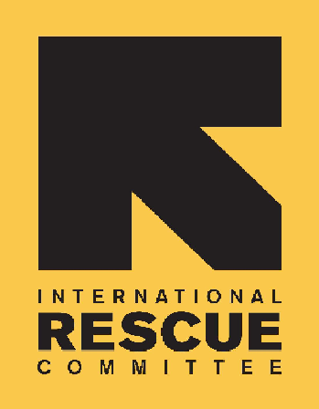
INTERNATIONAL RESCUE COMMITTEE, INC.
(Sudan Program)

BID NOTICE

Founded in 1933, the International Rescue Committee is a global humanitarian leader that helps people whose lives and livelihoods are shattered by conflict and disaster to survive, recover, and gain control of their future.

In partnership with EU, the IRC is undertaking a Rehabilitation and Installation of water sources in Blue Nile State.

Required as follows:
The IRC is issuing Request for Proposals (RFPs) to solicit competitive sealed bids from qualified companies for: |  | IRC/2SDN/TEN/2025/002
Lot A | Rehabilitation of Mini Water Yard in Salble WS - Baw Locality, Blue Nile State | - BOQ 1 - Rehabilitation of Mini Water Yard in Salble WS - Baw Locality, Blue Nile State
Lot B | Installation of Submercible Pump Aat North Damazine Area_DMZ Locality, Blue Nile | BOQ 1 - Installation of Submercible Pump at North Damazine Area_DMZ Locality, Blue Nile
Lot C | Daralsalam Gogish Rehabilitation of Borehole & Transmission Pipeline 3"_DMZ Locality, Blue Nile | - BOQ 1- Daralsalam Gogish Rehabilitation of Borehole & Transmission Pipeline 3"_DMZ Locality, Blue Nile
Lot D | Block 50_Rehabilitation of Borehole & Elevated Water Tank_DMZ Locality, Blue Nile | - BOQ 1- Block 50_Rehabilitation of Borehole & Elevated Water Tank_DMZ Locality, Blue Nile
Lot E | Rehabilitation of Mini Water Yard in Al Garri 2 WS - ArRusaires Locality, Blue Nile State | - BOQ 1- Rehabilitation of Mini Water Yard in Al Garri 2 WS - ArRusaires Locality, Blue Nile State

Offers will not be accepted after close of business on the 27th of July 2025 at 4pm Central African Time

